Create a list template

- Open the list that you want to save as a template.
- If you're in SharePoint Online, click Settings and then click List Settings.
In other versions, click List on the ribbon, and then click List Settings.
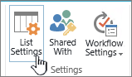
- In the Permissions and Management column, click Save list as template.
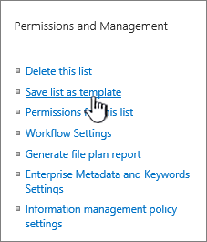
The Save as Template page appears.
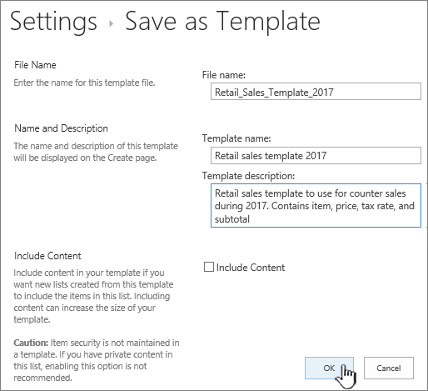
- In the File Name box, type the file name to use for the template file.
Note: Don't add a file extension to the file name. The .stp file extension is automatically added for you.
- In the Template name box, type the title that you want to appear in the list template gallery for this template.
- In the Template Description box, type a description for the template. The description appears in the details pane on the right when you select the template in the template gallery.
- To include the content that is currently in this list in the new list template, select the Include Content check box.
Note: This step does not save any security settings that may have been applied to the list. Because of this, we highly recommend that you save this list template to a secure place so that it cannot be restored by someone who should not have access to this content.
- Click OK.
You'll get a successful save confirmation screen if all went well.
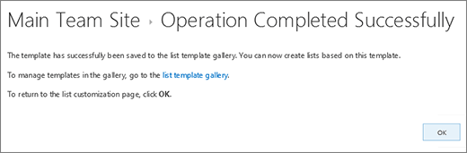
Click the Template Gallery link to see the new list template in the list template gallery.
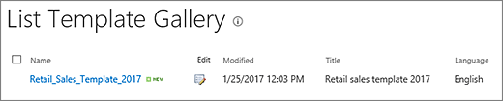

Create a list in SharePoint
- Click Settings and then click Add an app.
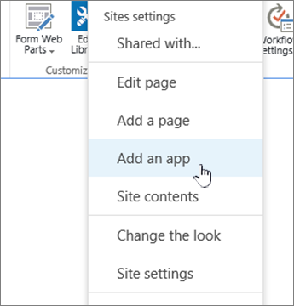
- Type the type of list template you want (saved list template name, custom, task, calendar, etc.) into the search box, and click Search.
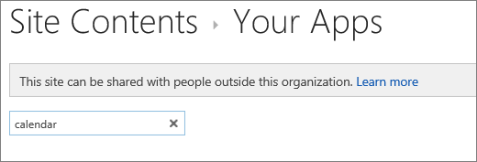
- Click the List template app you want use.
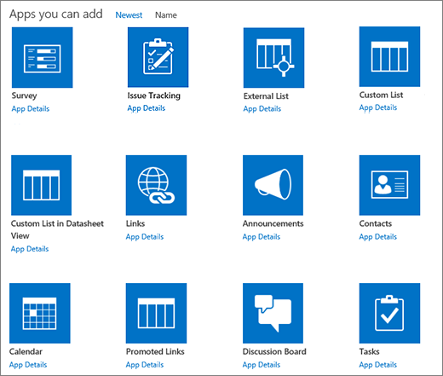
- Type in a Name (required).
The name appears at the top of the list in most views, becomes part of the web address for the list page, and appears in site navigation to help users find the list. You can change the name of a list, but the web address will remain the same.
You can also click Advanced Options. Advanced Options lets you put an optional Description and additional information, depending on the particular list app.
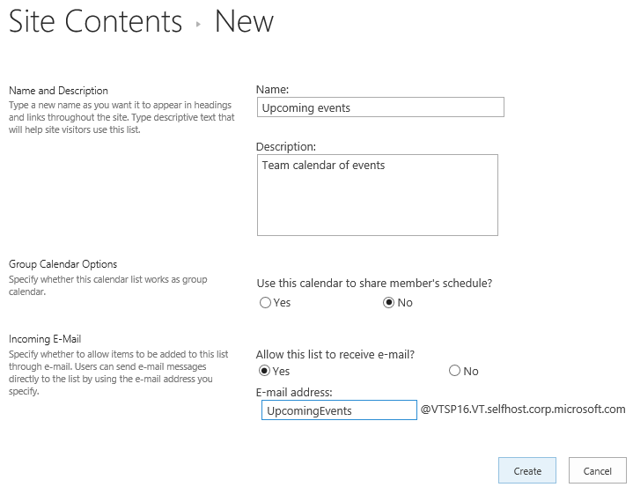
- Click OK.

Add a list to a page in SharePoint Server 2016 or SharePoint Server 2013
- On the page that you want to add the list or library, click Page and then click Edit. If you don't see the Page tab, click settings , and then click Edit Page.

Note: If the Edit command is disabled or doesn’t appear, you might not have permission to edit the page.
- Click the place on the page where you want to display the list or library, and click Insert and then click App Part.
- Select the App Part for the list or library and then click Add. You should see any lists you created in Add apps.
- When you’re finished editing the page, click the Page tab, and click Save. In some cases, you have the option to Save as Draft or Save and Publish.
Important: Some pages can't be edited, such as the Site Contents page.
Here’s an example of a list that was added to a page by using the previous steps.

Data Move App
We have only one web part which having both function
- Move data from current list to archive list
- Delete data from current list
For both functionality we have provided two buttons move data and delete data
There is two text box which is as following
- From Date (Start Date)
- To Date (End Date)
Move button moves data between two selected date and delete data between two selected date
Note:
- Before deleing data from current check first that archive list data is correct
- Once you delete you can not restore !

